51.2.2.5 ADR Sales Order Browse
What is ADR goods? The internet is saying below …
ADR is an abbreviation for "Accord européen relatif au transport international des marchandises dangereuses par route", which translates as "The European Agreement concerning the International Carriage of Dangerous Goods by Road."
ADR includes a special procedure in road traffic related packaging, cargo insurance and labeling of dangerous goods. Thus, ADR transport regulations relating to the carriage of dangerous goods. There are a total of nine classes ADR goods.
LQ (Limited Quantity) refers to small receptacles (typically of the sort that go into the retail distribution chain) which are packed in boxes or on shrink-wrapped trays).

Via this function we are checking so called ADR points of HRX chemical products (glues/cleaners = hereinafter G/C) and for a particular loading.
In QAD these chemical products are marked as # in column Description 1 and also you can recognize them by filled the column UN nbr.
Up to 999 ADR points the goods is allowed to be transported by an ordinary/standard truck.
From 1000ADR we are talking about FULL ADR truck and a special car/driver with a proper license may to handle with such big Qties only. A special license of a car/driver is a MUST! In such a case we have to inform our logistics or our customer (if they arrange their own transportation).

Column 2 + 3: means Packaging Groups 2 + 3 based on which ADR points are automatically calculated here based on units from column Qty Open. Usually there are units only in Packaging Group 2 and 3 is very often empty (depends on product).
Each ordered unit = 3 ADR points.
Total: it is the sume of all units from packaging group x 3 ADR points.
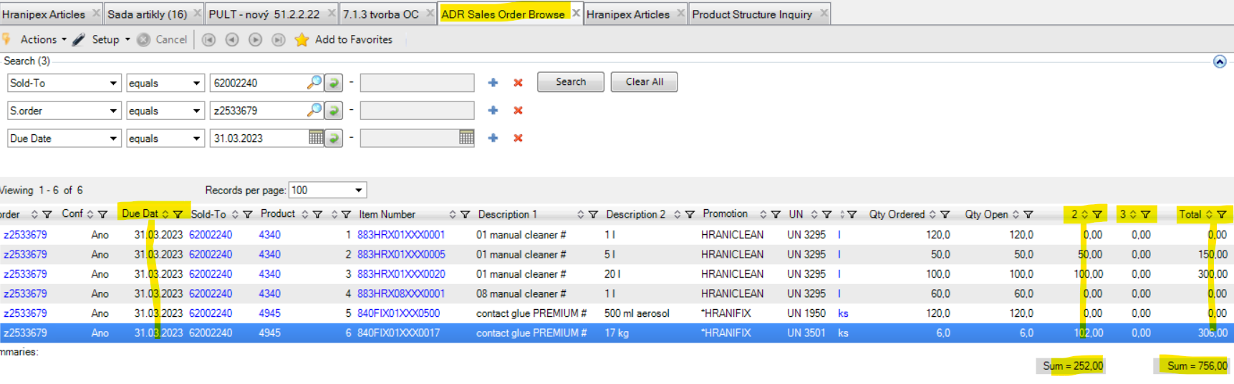

Up to 999 ADR points we are ok.
From 1000 ADR points it has to be discussed.

